**Joseph Tierney**

**Communications**

**Case Study**

**Computer Science 2**

**Contents**

Terms of Reference ………………………………………………………………………………………3

Method of Procedure …………………………………………………………………………………..3

Introduction …………………………………………………………………………………………………3

Findings ……………………………………………………………………………………………………….4

Conclusion …………………………………………………………………………………………………..7

Recommendations ………………………………………………………………………………………7

Bibliography ………………………………………………………………………………………………..8

**Terms of Reference**

This is a study devoted to understanding the communication structure in Dunnes Stores, primarily their store in the Pavilions. This case study is part of the QQI Level 6 assessment.

**Method of Procedure**

Many different types of research methods were used in this case study. It shows the communication techniques spread throughout the company. It contains interviews from employees who work in different sectors. This showed how different sectors communicated with each other. It also contains observations from myself as the employees carried out their daily tasks.

**Introduction**

This case study will examine the management structure, different types of communications, how effective they are and recommendations that could be made in how to improve the communications. The conclusion of this report which includes the findings, about the research and any improvements that could be made in communicating in the company and the bibliography containing references. The findings from this study will be used to enhance the communication skills and how information is passed through the store.

Dunnes Stores has over 100 stores throughout Ireland, the UK and Spain. They employ almost 15,000 people. They are Ireland’s largest and leading retailer. On the 31st of March, 1944, Ben Dunne used his savings to open the first ever Dunnes Stores on Patrick Street in Cork. Word spread quickly through the city of the bargains on offer. People flooded the store to buy items at pre-war prices I what was termed a ‘shopping frenzy’. The words Better Value were engraved across the shop and those who went knew the truth of Ben Dunne’s philosophy. Dunne opened his first Dublin branch in 1957 on Henry Street followed by a super-store on South Great Georges Street in 1960. Shoppers were allowed to browse through items on shelves before making a purchase, a completely new idea in Irish retailing. So began the aim of Dunnes Stores to innovate in order to put the customer first. In the visionary spirit of Ben Dunne, Dunnes Stores continues to evolve.

**Findings**

Communication is essential in the workplace, without it the workplace would crumble and fall apart. There are many different types of communicating in the workplace, there is visual, written and verbal communication. Visual communication exists in every workplace. Visual communications range from personally designed signs or posters, colourful prostrations to creative emails. This type of communication can keep an employee happy and motivated to do their job.

Written communication is used for writing repots, completing documents and emails in the workplace. This type of communication is very important as the managers have written proof of the documents which makes it easier for them to communicate with each other.

To ensure a successful working environment, Verbal communication is essential. Verbal communication isn’t just talking, it can be work terminology, which can be used in meetings and group discussions.

Formal communication is the official structure of an organisation. In Dunnes Stores, formal communication is used once a month, this involves managers and personnel holding a meeting with the staff members in order for them to keep up to date with what’s happening in the store, what their sales quotas are, if there’s any problems occurring and if they need to do a stock take for the following month.

Lateral communication is a method of exchanging information between different departments, usually between people on the same level of the hierarchy. Horizontal communication can be seen in Dunnes Stores between their drapery and grocery departments, and even different Dunnes Stores around Ireland. Managers for these departments typically email one another (if they’re local to one another, they usually use verbal communication and meet face-to-face – source, grocery store manager), discussing promotional sales, staff performances and even staff relocating. This can also be found between the department manager and the store manager. Both managers will email one another about upcoming sale targets, staff performances and issues and who is scheduled to work on what day.

Grapevine communication can be found all throughout Dunnes Stores. In both the drapery and grocery departments, there are many cliques. Many of the cliques are members of staff, whom are very close to one another. They organise staff get-togethers and events in the workplace, rather than the managers themselves as they “don’t have the time” or are simply not interested. They inform their fellow employees of these events through a noticeboard which is placed just outside the lunch room. This seems to be the only use of the noticeboard within Dunnes Stores. Cliques in the grocery department often communicate with those in the drapery in order to find out when and where they’ve organised their staff event as to not conflict with it.

Sometimes, although very rarely, employees will skip talking to their department manager and go straight to the store manager, and even personnel, if they encounter a problem, or have a request. This is a form of upward communication. Despite being able to talk directly to the store manager or personnel, no employee is allowed to directly talk to head office without any of the higher chain of command (department manager, store manager and personnel) knowing about it, and managers will only contact head office for an employee if there is a serious, continuing problem in the work place.

In Dunnes Stores, the most used type of communication is verbal. All day-to-day operations, be it with a manager or a staff member all involve verbal communication. It’s most commonly seen at the customer service desk – where staff help and serve customers, but also between managers, their employees and the stores suppliers. In my observations, employees socialize together while working using verbal communication. Unfortunately, for floor staff this is frowned upon as managers believe they won’t get their work done and see it as very unprofessional to be talking about outside interests in work when around customers and higher levels of management.

While observing the employees carry out their daily tasks, I noticed various methods of non-verbal communication being used. The Health and Safety team in both the grocery and drapery departments use hand gestures when they find a spill or broken item that can be hazardous to shoppers on the floor, signalling that they need someone to watch over it until they return with the equipment necessary to clean it up.

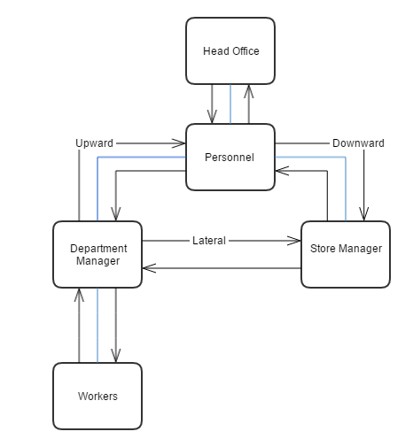

Flow chart showing the organizational structure of Dunnes Stores.

Pie Chart showing the most used methods of communications within Dunnes Stores.

**Conclusion**

This case study shows the different communication types throughout Dunnes Stores. These include; verbal, non-verbal, formal, grapevine, lateral, upward and downward communications have been shown. Communication is easily spread out through the store by verbal communication.

**Recommendations**

Recommendations that could be made to for both departments – managers should organise staff events every so often, they don’t necessarily have to organise them all the time, but every once a while, in order to show that just like the employees, they are part of the Dunnes Stores team. This would likely increase overall morale, as it would make the staff feel like the managers want to socialize with them. Another recommendation would be to not be so strict with floor staff talking and communicating with one another while working, this could increase work rate and make them a lot happier and possibly more productive while doing their work.

**Bibliography**

Tierney, C. (2016). *Communication in Dunnes Stores*.

Limited, B. (2016). *Dunnes Stores | Head office | Dunnes Stores | Dunnes Stores*. [online] Dunnesstores.com. Available at: <http://www.dunnesstores.com/head-office/content/fcp-content> [Accessed 15 Jan. 2016].

Limited, B. (2016). *Company Overview | Largest and leading retailer | Dunnes Stores | Dunnes Stores*. [online] Dunnesstores.com. Available at: <http://www.dunnesstores.com/company-overview/content/fcp-content> [Accessed 17 Jan. 2016].

Limited, B. (2016). *Our Story | History of Dunnes Stores | Dunnes Stores*. [online] Dunnesstores.com. Available at: <http://www.dunnesstores.com/our-story/content/fcp-content> [Accessed 21 Jan. 2016].